Daily User - Troubleshooting
- Offline/Disconnected Devices

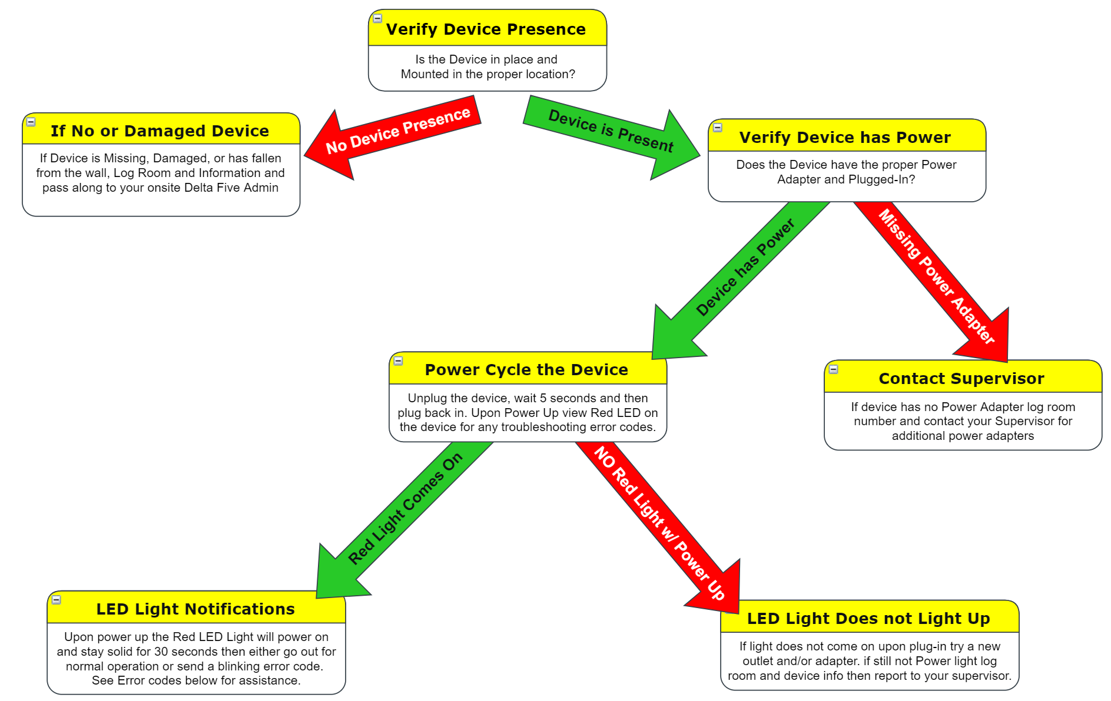

Normal Operation for Devices:
After 30 second solid power up the light should without blinking

All other codes – Log room/device and error code info and report to Supervisor/on-site expert
Examples of Code Sequence to Report: 2 short blinks three, 4 short blinks three, 5 short blinks three

Alerted Devices - How to Deal with an Alert
1
2
3
Once the drawers are closed, using the Tab pull the
chamber from the device as shown in Figure 4
If the device is Alerted, ensure both doors are
fully closed prior to
removal for visual inspection
as shown in Figure 3
Check the device to see if the
device is alerted. If the LED
button on the side of the
device is red, then it is Alerted
As shown in Figure 2

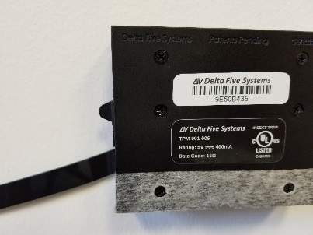
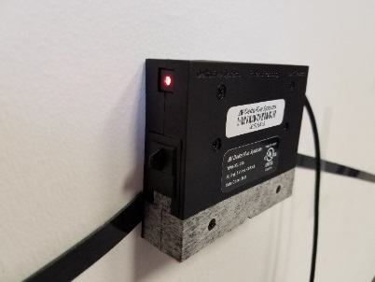
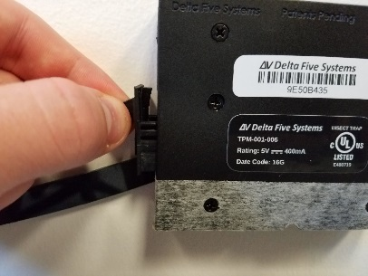
Figure 3
Figure 2
Figure 4

4
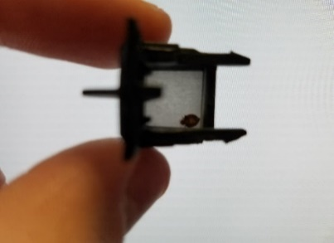
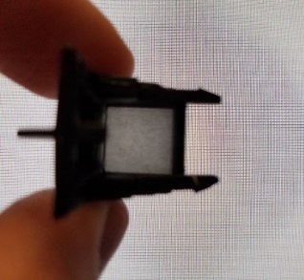
With the Chamber removed inspect the chamber
for any Pest as shown below in Figure 5.
If there is anything within the drawer, place the chamber
into a bag, write the room number on the bag, and report
it to your supervisor.
After removing the drawer ensure to clean out or replace
a new drawer within the opened device

Figure 5

6
5
Press and release the Red Alerted button
to reset as shown in Figure 7.
If nothing found within the drawer,
place the drawer back into the device
Note: chamber doors must be closed to
be re-inserted into the device
Once chambers are re-inserted into the
device ensure both doors are opened
as shown in Figure 6

Figure 7

Figure 6

The light should go out and the device
will reset to the dashboard.
Reset is now Complete

LED Light Code Meanings and Possible Fixes
*All blinks will be a sequence of 3

Blinking 1 Times per second indefinitely
Error: Device requires Wi-Fi credentials
Solution: Complete the Wi-Fi configuration Process (illustrated in the Supervisor Guide)

2 short blinks three times
Error: Device cannot connect to the wireless network
Cause: Password input error upon configuration, device whitelisting error
Solution: Reset and Reconfigure Wi-Fi
- STEP 1: Press and holding the Red LED Light/Button for 10-15 seconds, the device will then be blinking 1 time per second letting you know it is awaiting Wi-Fi configuration.
- STEP 2: Complete the Wi-Fi configuration Process (illustrated in the Supervisor Guide)

4 short blinks three times
Error: Device cannot connect to the Delta Five Server
Solution: Reset and Reconfigure Wi-Fi
- STEP 1: Press and holding the Red LED Light/Button for 10-15 seconds, the device will then be blinking 1 time per second letting you know it is awaiting Wi-Fi configuration.
- STEP 2: Complete the Wi-Fi configuration Process (illustrated in the Supervisor Guide)

5 short blinks three times
Error: Device cannot receive a proper response
Solution: Unplug device and plug back in
*note if this does not correct the error please double check the whitelisting for the device.

Supervisor’s Section
Saving Wi-Fi Configuration to Device
How to reconfigure and save the wireless information

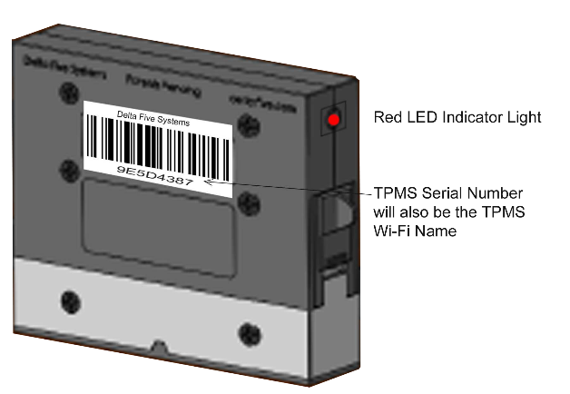
*note if adding a new device to your property ignore step 1 as the new device should already be in pairing mode.

Step 1.
Press the LED Button and hold for 10-15 seconds.
When button is released the Red LED light should
be blinking 1 time per second and ready for pairing.

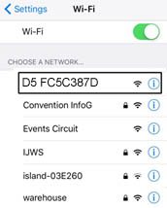
Step 2.
Using a Laptop/Mobile Device open the Wi-Fi settings
and find the list of available Wi-Fi Networks,
The Device ID should be listed in the network list available.
Connect to the Device Network from the available
Wi-Fi networks list the device will be named ` D5 [Serial-Number]`
*Please note you must remain connected
to the Device’s Wi-Fi to complete the pairing.

Step 3.
Next on the same Laptop/Mobile Device from Step 2,
Open a web browser and type the web address `192.168.0.1`
The page that loads will scan for a moment then list all the available
networks within range of your D5 Device.
Select the desired network and type in your Wi-Fi password if applicable,
then click the green Save Configuration
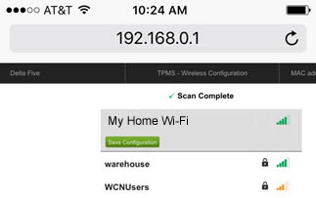

Supervisor’s Section
Factory Ressetting a Device
When to Complete a Factory Reset:
- Device Alert light is illuminated and will not reset with button press or power cycling
- Device Alert light does not illuminate upon power up
- If all other steps have been completed and device is still not syncing with the dashboard

How to Complete a Factory Reset:
Depending on outlet location this process may require 2 people

- Unplug the Device
- While unplugged press and hold the LED Button
- Continue holding the button and plug the device in
- After plugging in continue to hold the button for approx. 20 seconds until the light blinks rapidly
- Release the button and wait a brief moment until the light begins to blinks 1 time per second
- The device has now been Factory Reset and is ready for the Wi-Fi configuration process.

