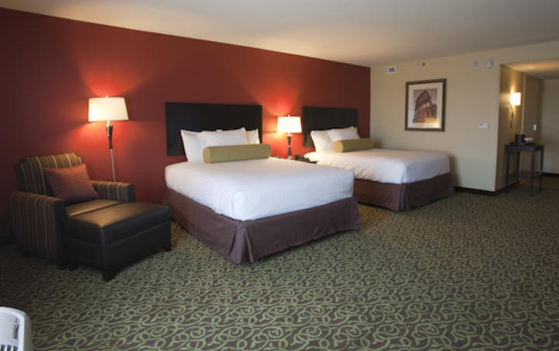
Overview
Every morning a list will be delivered to your email address. This list will contain a number of devices that currently need attention. On this list, the devices are given names based on the room number and bed placement (The queen sized rooms will contain an “A” or “B” depending on the bed.) The A listed device is the beds on the left, and B listed device is the bed on the right. This can be seen in Figure 1. For example, the device behind the right bed in room 11023 would be called RM 11023 B.
A B

Figure 1

How to Deal with an Alert
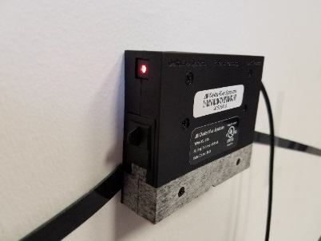
- Check the device to see if the device is alerted. If the button on the side of the device is red, then it is alerted. As shown in Figure 2.
Figure 2

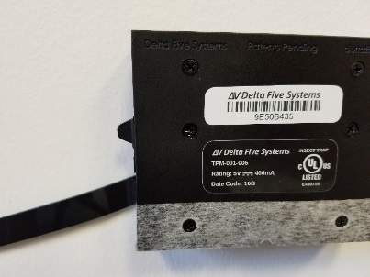
- If the device is alerted, close the drawers as shown in Figure 3.
Figure 3

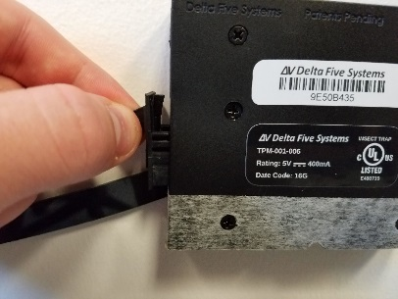
- Once the drawers are closed, pull the chamber out as shown in Figure 4.
Figure 4
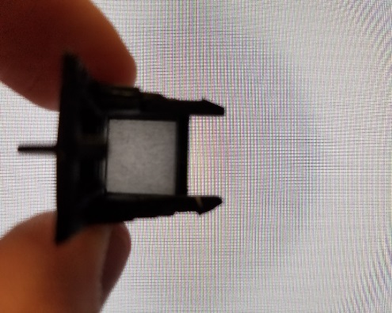
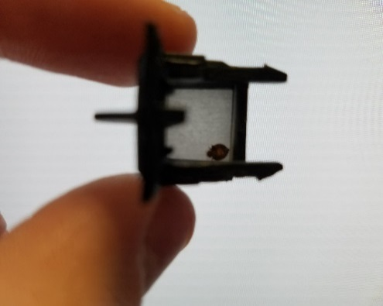
- Inspect the drawer.
Figure 5

- If there is anything within the drawer, place the chamber into a bag, write the room number on the bag, and report it to your supervisor. Also, after removing the drawer clean out or replace a new drawer within the opened device.

- If there is nothing within the drawer, place the drawer back into the device.
- Open both drawers in the chamber as shown in Figure 5.
Figure 6
- Press the button on the device as shown in Figure 6.
Figure 7

How to Deal with a Disconnect
- Check to see if the device is unplugged, if it is unplugged plug it back in and you are done.

- If the device or adapter is missing, report the room to your supervisor.

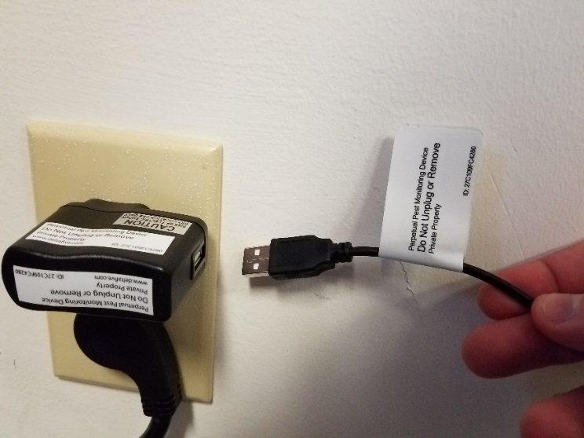
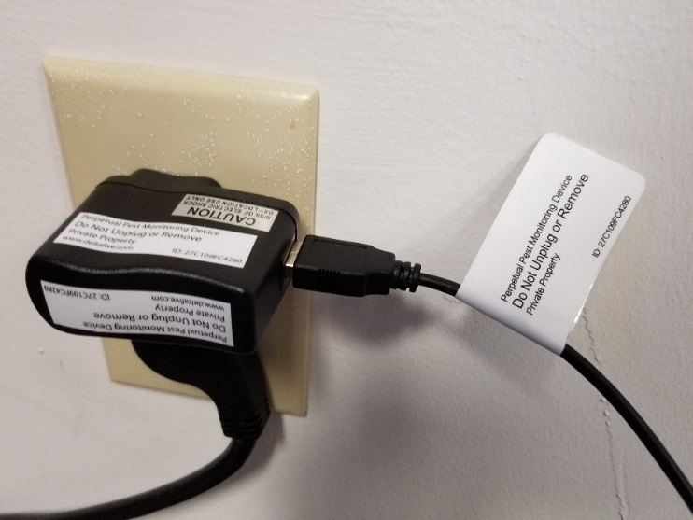
- If the device is already plugged in, then you will need to reboot it. To reboot the device, simply unplug the USB from the adapter, wait five seconds, and plug it back in as shown in Figure 8.
Figure 8

