Factory Ressetting a Device
When to Complete a Factory Reset:
- Device Alert light is illuminated and will not reset with button press or power cycling
- Device Alert light does not illuminate upon power up
- If all other steps have been completed and device is still not syncing with the dashboard

How to Complete a Factory Reset:
Depending on outlet location this process may require 2 people

- Unplug the Device
- While unplugged press and hold the LED Button
- Continue holding the button and plug the device in
- After plugging in continue to hold the button for approx. 20 seconds until the light blinks rapidly
- Release the button and wait a brief moment until the light begins to blinks 1 time per second
- The device has now been Factory Reset and is ready for the Wi-Fi configuration process.

Saving Wi-Fi Configuration to Device
How to reconfigure and save the wireless information

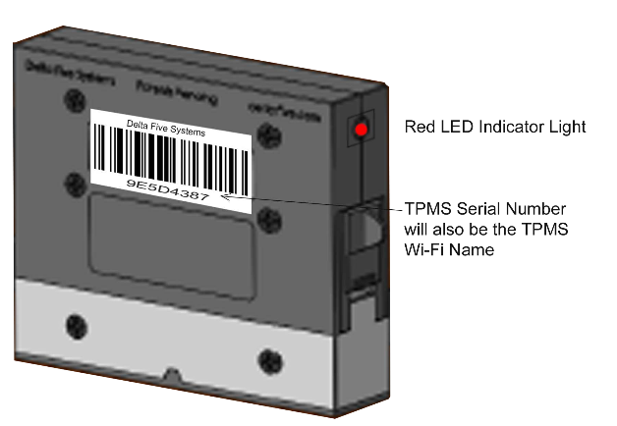
*note if adding a new device to your property ignore step 1 as the new device should already be in pairing mode.

Step 1.
Press the LED Button and hold for 10-15 seconds.
When button is released the Red LED light should
be blinking 1 time per second and ready for pairing.

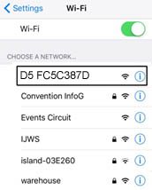
Step 2.
Using a Laptop/Mobile Device open the Wi-Fi settings
and find the list of available Wi-Fi Networks,
The Device ID should be listed in the network list available.
Connect to the Device Network from the available
Wi-Fi networks list the device will be named ` D5 [Serial-Number]`
*Please note you must remain connected
to the Device’s Wi-Fi to complete the pairing.

Step 3.
Next on the same Laptop/Mobile Device from Step 2,
Open a web browser and type the web address `192.168.0.1`
The page that loads will scan for a moment then list all the available
networks within range of your D5 Device.
Select the desired network and type in your Wi-Fi password if applicable,
then click the green Save Configuration
